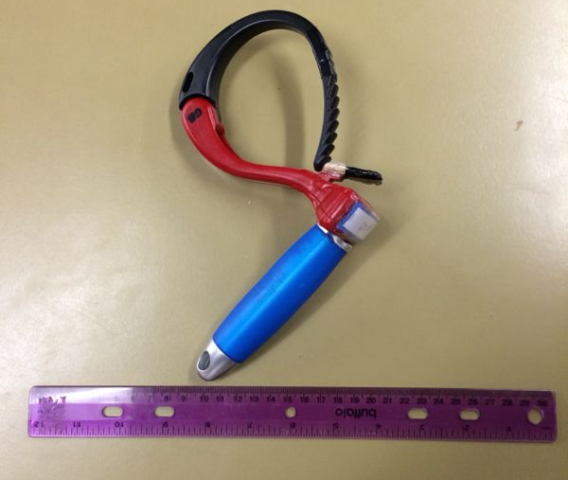  Grip⁺ | 
 | Freedom⁺
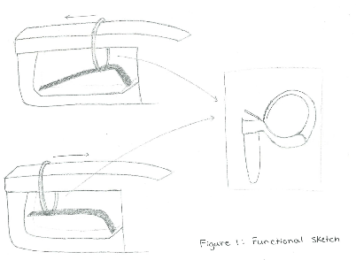
F 19 - 124- 9
Figure 1: Grip⁺, a truly simple approach to solving a complex problem. | Figure 2: A diagram demonstrating how Grip⁺ works

Problem Description
Design a device for the client Dr. Fleisig that helps Sandi maintain her independence at the gas station by reducing the pain caused by the dispensing of gasoline.

Design
Grip⁺ is lightweight, compact and simple; everything one would need to simplify their experience at the gas station. Its dimensions are 12 cm by 26 cm, allowing it to fit in any purse glove box or back pack. It weights not a gram more than 156 grams, allowing for worry-free and effortless transportation.

Functionality
When we at Freedom⁺ were designing this, we wanted to make a device that helped, a device that would see people regain their independence one step at a time. Grip⁺ does exactly that, giving users a way to refuel their cars without the need to refuel their energy after this problematic task. It maintains their independence and allows users to feel one thing; free.

Materials, Components, and Assembly
Grip⁺ is made of 3 different materials, a cable wrapper, a hair brush and contact cement. The total cost of this device is $16.44, something so minimal if compared with the services it provides. It takes no longer than 30 minutes to construct, a proof of its ergonomic design.

Use
To demonstrate how easy Grip⁺ is to use; we have enclose instructions on how to use it.
- Arrive to the gas station, exit vehicle and select fuel gradient.
- Open the devices arm by pushing down on the lever.
- Wrap the arm around the part of the nozzle that is smallest in diameter (as seen in Figure 2).
- From there, Sandi must simply pull the handle of Grip⁺ away from the car.
- In order to remove it, she can let go of the handle, it will return to the starting position and the arm can be unwrapped.

Benfits
Upon speaking to Ms. Mugford, it was fairly clear that the entire experience of going to the gas station was a tiresome and prolonged one. She had problems doing everything from swiping her credit card and using the pin pad, to gripping the gas nozzle to pump the gas. While all of these problems are equally stressful to Ms. Mugford, it must be noted that the only problem to which Ms. Mugford has not devised any alternative to solving was the one involving pumping the gas. In order to pay for the gas, Ms. Mugford was always presented with the alternative of using the payment options inside the gas station, meanwhile she had never found any alternatives to pumping the gas (the main purpose of coming to a gas station).

It is therefore clear that in order to solve Ms. Mugford’s issues at the gas station, one must solve the most painful and complex sub-problem: the problem of refuelling her car.

Grip⁺ is a device that focuses on an approach to solving all of Ms. Mugford’s problems with one main objective in mind: ease-of-use. Seeing as our client has Rhumatory arthritis, the solution that would suit her most is one that would make her experience at the gas station natural, ensuring it becomes something she does not have to even think about. For this reason, the design of Grip⁺ is simple, light-weight, ergonomic and most importantly discrete. Again, all these qualities of the product are there to make the process as easy as possible.

While a complex robot that would pump gas for our client would be at first considered an ideal solution, it must be taken into account that this solution is not pragmatic. The solution must make the user feel natural, worry free, and give them a painless gas experience. For this reason, Grip⁺ is a solution that allows for an efficient and quick pumping experience.

The silicone grip on the handle of the Grip⁺ is perfect for users with Rhumatory arthritis as it is form fitting, comfortable and weather durable. Most other materials tend to harden when winter arrives because of the colder average temperatures. However, due to the thick silicon coating, Grip⁺ provides users like Sandy who have joint pain with a handle that will minimize the physical stress of pumping gas.

Another feature that was added to ease the experience of users was the extension of the lever used to open up the clamps that go around the gas nozzle. This lever allows for a larger surface area that is to be pressed, thus decreasing the need for precision and specific joint pressure. This not only makes the device easier to use, it also reduces the need for complicated locking mechanisms that are heavy by nature. It is another part of the design that is lightweight and sleek, making the device both discrete and convenient.

Those who suffer from conditions such as Rhumatory Arthritis pay thousands of dollars a year for medication and devices that are to help them live a comfortable life. With that in mind, the device that they are to use at the gas station must be as affordable as possible. The simplicity of Grip⁺ allows it to be extremely price-friendly, something that is very beneficial to users who already pay so much to lead a healthy and easier life.

The simplicity of the design allows for the device to rarely experience any mechanical failures and to be extremely easy to repair, making for a basically maintenance free object. If a device is to help Ms. Mugford with her daily life, then it must be durable, consistent and reliable. With this in mind, the device is extremely resistant to the possible wear-and-tear that one would experience at the gas station, seeing that it may possible be dropped. She should not be worrying about potential device failure, as that would cause the device to be a nuisance rather than solving her problem.

Grip⁺ has a compact and lightweight design that allows for storage where-ever the user so desires. For instance, Ms. Mugford tends to keep her purse in the trunk of her car, allowing for storage of the device inside her purse, the glove box, or even the mesh in the trunk of the car. This gives users more freedom and independence, something that Grip⁺ is dedicated to doing.

Grip+ provides a sense of real, uninterrupted freedom. The functional and discrete design is there to make it feel less like a product, and more like a natural feature and extension of their daily routine. Grip+ is there to help as discretely as possible, enabling users to have more time and energy for all the other aspects of daily life.

